Cygnet PCN PPG Newsletter

Winter 2025 / Early 2026 Edition
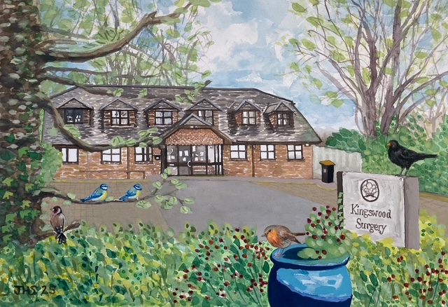

What has the PPG been discussing?
At our most recent meeting, we talked about:
- Access to GP services and how the new triage and online systems are working,
- Patient experiences of contacting the surgery and receiving timely appointments,
- How practices across the PCN are supporting one another,
- Plans to refresh the PPG, including holding an Annual General Meeting (AGM).

Members shared positive feedback about the new access model, with several people describing how reassuring it feels for the practice team to assess urgency, rather than patients having to judge this themselves.

Looking ahead – what will the PPG focus on next?
Over the coming year, we want the PPG to be more purposeful and patient led. Our priorities include:
🔄Refreshing PPG membership
Re-electing or confirming existing members and welcoming new ones, so the group reflects our patient population and has clear roles and expectations.
💉 Supporting flu clinics and key health campaigns
Helping promote clinics, sense-check patient messaging, and act as patient advocates for why vaccination and prevention matter.
📋 Patient surveys
Supporting the national GP Patient Survey and leading a local survey focused on Enhanced Access, to help understand patient experience in more detail.
👥More engaging meetings
Holding face-to-face meetings every two months, with occasional guest speakers (such as GPs or other professionals) to keep discussions informative and relevant.

New for 2026: Meet the Practice Team
In future newsletters, we’ll be introducing members of the practice team to help patients understand who’s who at their surgery and how different roles support care. We’ll be starting with our reception team, often the first point of contact for patients and a vital part of keeping services running smoothly.

Patient Participation Group AGM – Save the Date
We will be holding our PPG AGM in February; this will be an opportunity to:
- Elect a new Chair and supporting PPG roles,
- Share what the PPG has been working on,
- Discuss priorities for the year ahead,
- Welcome new members and fresh ideas.

Interested in joining the PPG?
You don’t need any special experience, just an interest in improving patient services and representing the wider patient voice. You can be involved as much or as little as suits you. If you’d like to join the PPG, speak to your surgery reception team or email admin@cygnetpcnbucks.com. You can also scan the QR code below to visit the PPG page on the Cygnet PCN website and find out more. We’d love to hear from you.
. 

